**React Native Custom Template**

# Main Steps:

1. Creating the template's repository
2. Creating the app template (make the React Native project you want to use as your template)
3. Creating the actual template structure (the app template + other config files)
4. Testing it!

# Let's Start:

# First, it's convenient to tell you that this custom template can either be on your computer as a repository or on remote repositories on Github, Gitlab, Bitbucket so on..

# Your template can be called from npm, file://, http://, https://, or git://.

## **Initial Repo Setup:**

I'm going to setup a sample repository on Github called **testRNTemplate** (you can name yours whatever you want). This will contain the sample template for this article.

## 

## **Create Initial Template App:**

On your local machine, open the terminal and create an initial React Native App using

npx react-native init ProjectName

And run your App.

## **Installing Project Dependencies and Setup:**

I will install React Native TypeScript and UIKitten packages.You can install any packages for your custom template.

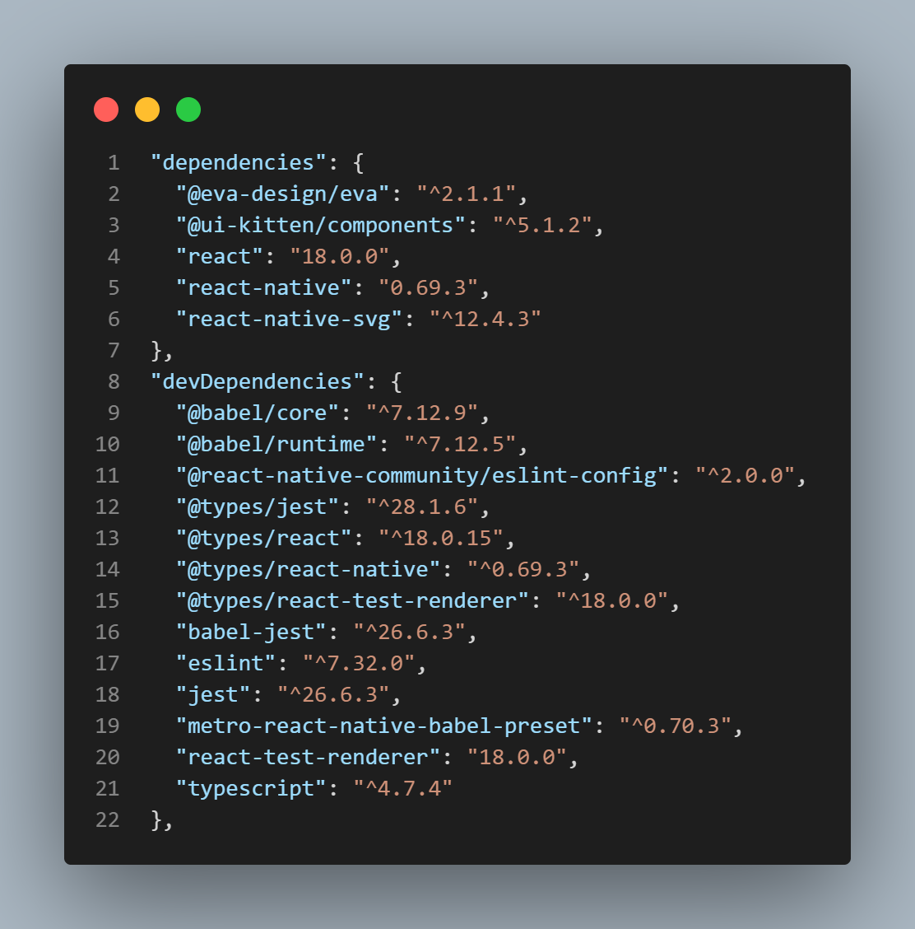

## **Testing new libraries on App.js (as a demo):**

We should check if the installation of the packages was successful by changing the code in our **app.js** with the following code below (you can copy paste it directly)

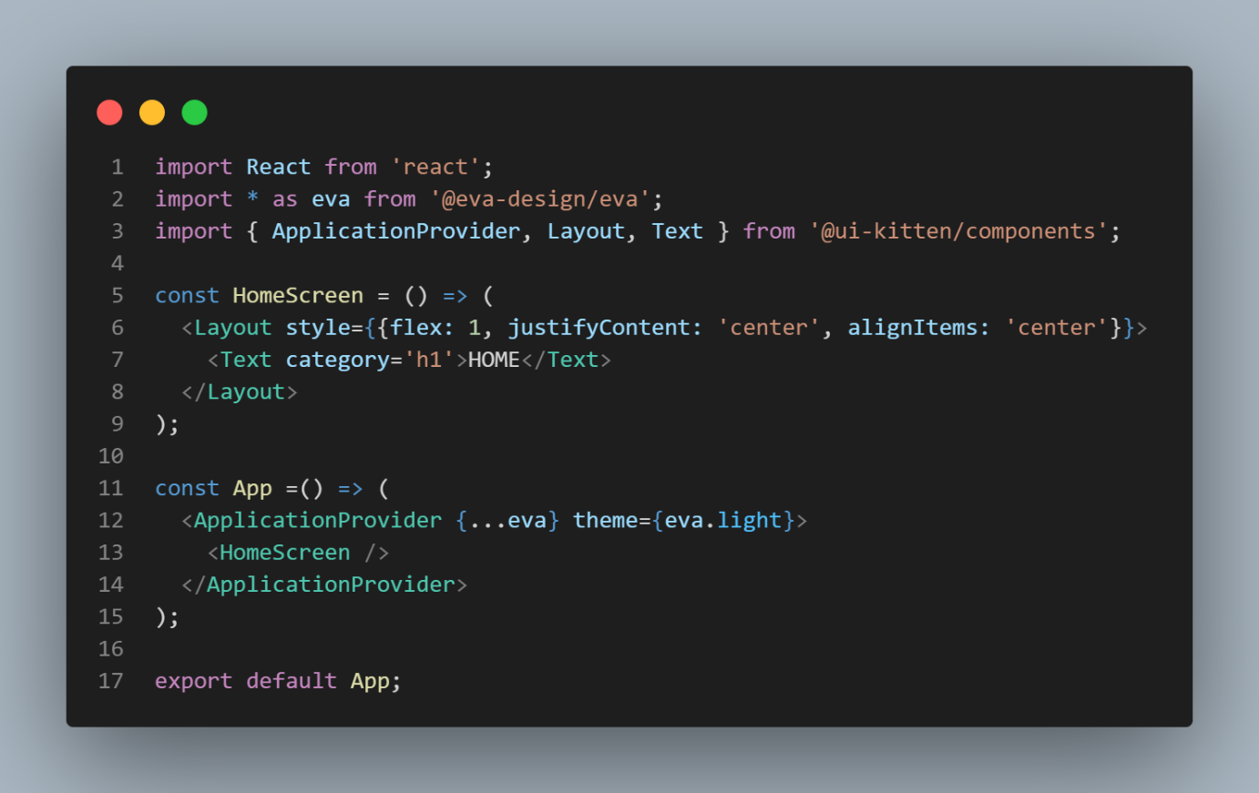

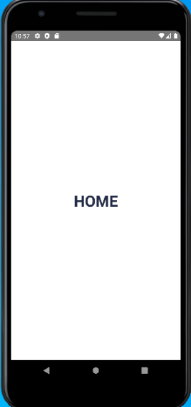Then run npm run android and npm run ios (if you are on mac). The result should be

From here, You can customize it based on your needs or just simply what you want your RN Template to look like. After that we can finally start making the template structure.

## **Creating the actual template structure:**

To make our custom React Native we need to create **template.config.js;**

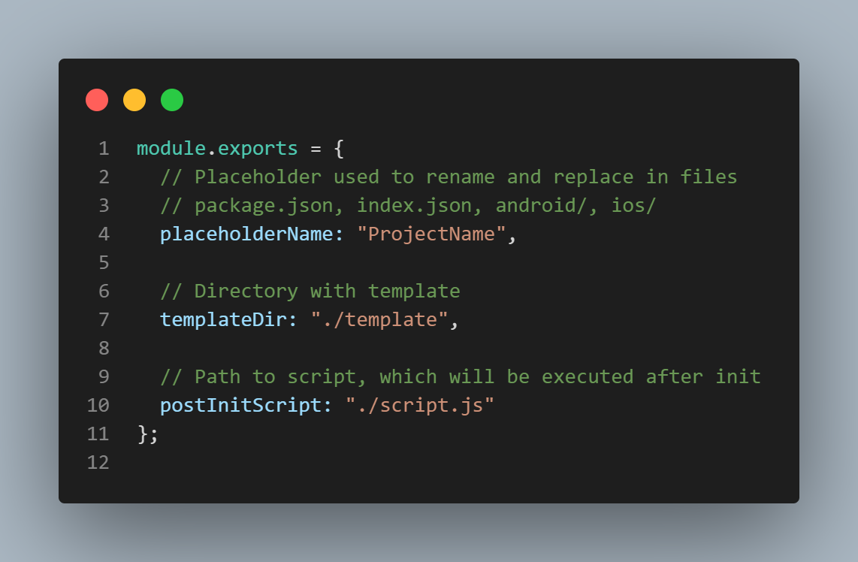

Then create **package.json;** You can add script.js;

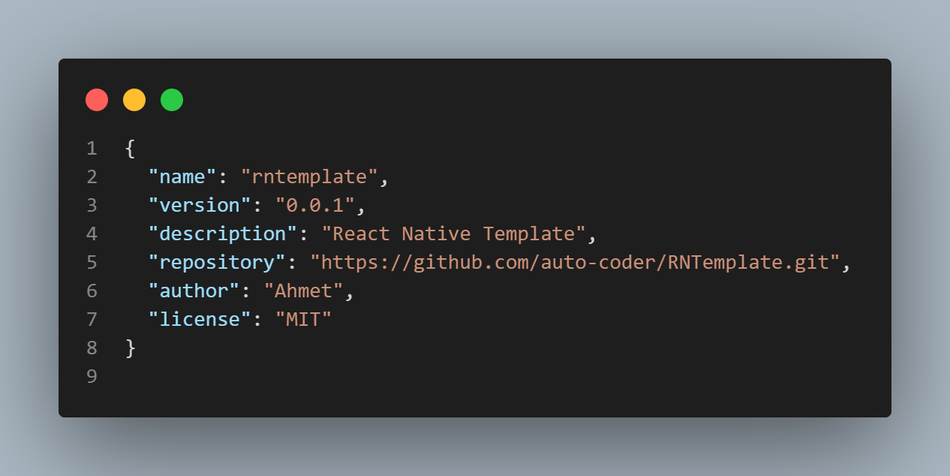

**Note:** Please remember to change your repository based on your specific repository because that repository is specific to the repository I made in Step 1.

Your project folder should be like this.

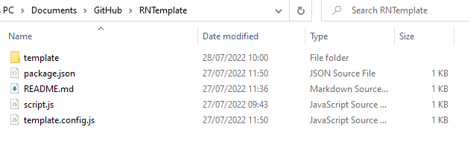

At the **testRNTemplate** folder, open a terminal and you can now push all of the code to the repository we created in 1.) using git. You can refer to these commands

Give it a try by opening a terminal and running

npx react-native init myApp --template <https://github.com/auto-coder/testRNTemplate>

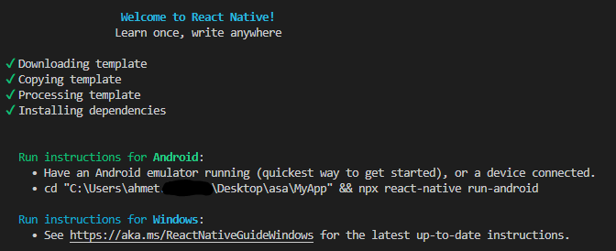Installation complete:

**Easy start custom template:**

Installing from npm is probably the easiest way to go, and [publishing to npm is SUPER easy](https://docs.npmjs.com/getting-started/publishing-npm-packages). Once published to npm, you’d use your template like so…

npx react-native init test --template testRNTemplate